**Summary on functionalities of existing typing tutors and listing desired functionalities for our own typing tutor**

**TypingTest.com**

I tried out the quick tour for it. I took most of the points here from their quick tour.

* Their approach to their typing tutor is called Touch Typing
* They have a motoric warm up, where they would show a virtual keyboard without the keys on it, we are to press the key where the stars appear without looking at the keyboard. The aim of this to stimulate the muscle memory. After the keys prompted has been entered correctly, score will increase for “Correct Hit” by 1 and if entered incorrectly “Misses” will increase by 1. At the end of the exercise it will also show you your accuracy which is calculated by the formula – ( (Number of keys entered correctly) / (Total number of keys entered) ) * 100%. The title of the activity will also be shown and is now completed.
* After going through this stage, the typing tutor will then introduce new keys to the user 2 to 3 at a time. The punctuation keys are also covered in the lessons. The keys that are to be typed are shown on the screen and is also highlighted on the keyboard. The accuracy of the stage is also recorded at the end. (If needed can look into the sequence of keys they introduce i.e from keys FR-JU and so on.) The combination of the keys being taught are arranged randomly and repeated twice, separated by a space (Randomizing FR and JU and later on combined and randomized of FRJU.) [FRFR_ FRFR_ JUJU_ JUJU_][FRJU_ FRJU_ JRFU_ JRFU] (_ representing spacebar)
* After all they keys are introduced, the next stage will now involve words. Each words is repeated 3 times and separated by a space. Keys are shown on the virtual keyboard at this stage. If a key is typed wrongly, the keyboard will then highlight where you are supposed to click it. Accuracy will also be shown at the end. Typing speed is added on this stage where it is calculated by Words Per Minute (WPM).
* The next stage will train the user to type sentences. At this stage the user is supposed to have mapped the keyboard in his mind and starts using the Enter key. Keys are now not shown on the keyboard. It will only assist the user when it detects a mistake. Accuracy and WPM is shown at the end of the stage. The teachings of sentences and words go by different regions on the keyboard (showing it in a picture would be much more simpler).

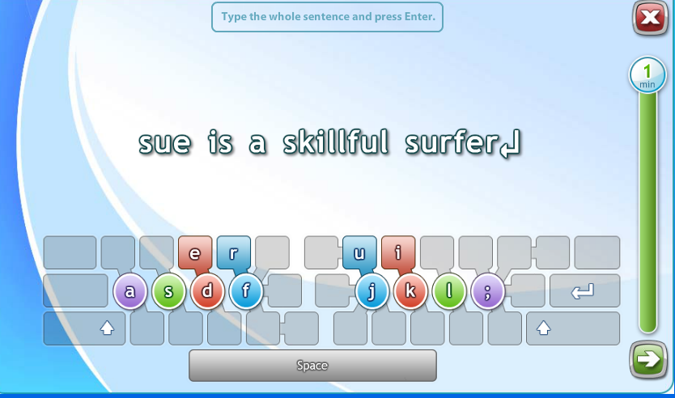

* Smart review. The typing tutor analyses the user at previous stages on words where the user is having difficulty in typing it. The amount of words that will be given for the smart review differs. The user will only be allowed to move on after typing the word correctly. User is tested 4 times for each word. Enter key is used to progress the stage. The size of the keyboard is also reduced as the user progresses.
* The last part of the typing tutor involves typing a full passage. Mistakes are allowed and underlined in red, backspacing is allowed for correcting the mistakes and the size of the keyboard on screen is reduced. It will then be hidden completely.

**Desired Functionalities of TypingTest.com**

* The ability to analyse the words the users are having difficulty in.
* The ability to calculate the accuracy and WPM.
* Learning by phases. 4 letters at a time and so on.
* Smart Review